Chip back potential is the level which bulk silicon is maintained by on-chip connection, or it is the level to which the chip back must be connected when specifically stated below. If no potential is given the chip back should be isolated.

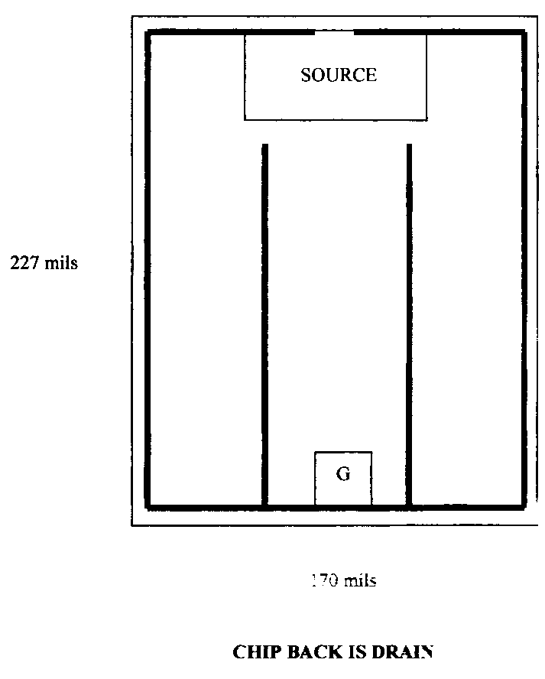

Top Material: Al
Backside Material: CrNiAg
G = .020” X .022”
S = .070” X .050”
Backside Potential: Drain
Mask Ref: GEN 3 HEX-4 60V N-Channel

APPROVED BY: DK DIE SIZE .170” X .227” DATE: 7/11/22
MFG: TEXAS INSTRUMENTS THICKNESS .015” P/N: IRFC044B
DG 10.1.2

Rev B, 7/19/02

